Project Design Phase
Problem – Solution Fit Template

Date | 3 october 2026
Team ID | SWTID-2026-8181
Project Name | Script-Controlled ACL – Restrict Record Access Based on Field Value
Maximum Marks
Problem – Solution Fit Template:
The Problem-Solution Fit in this project means identifying a record-access problem and showing that the proposed Script-Controlled ACL directly addresses it. The project focuses on a common authorization requirement: a user may have a valid account and role but should not automatically access every record. The ACL uses a record field such as department, classification, status, or access_level to make a more specific access decision.
Purpose:
❑ Solve the record-access problem in a way that fits the permissions and responsibilities of different users.
❑ Improve access control by using the existing application authentication, user roles, database records, and ACL evaluation process.
❑ Use clear access triggers and field-value conditions so that the authorization rule is easy to understand and test.
❑ Reduce unnecessary exposure of records by checking the requested record before allowing access.
❑ Understand the existing access situation and improve it through dynamic, record-level authorization.
Project Problem
Role-only permissions can be too broad when records belong to different departments or have different classifications. For example, an HR user should be able to access an HR record, while a Finance user should not receive that same record merely because both users are authenticated. The required solution is an additional field-value check at the ACL level.

Problem – Solution Fit Template:

Template:

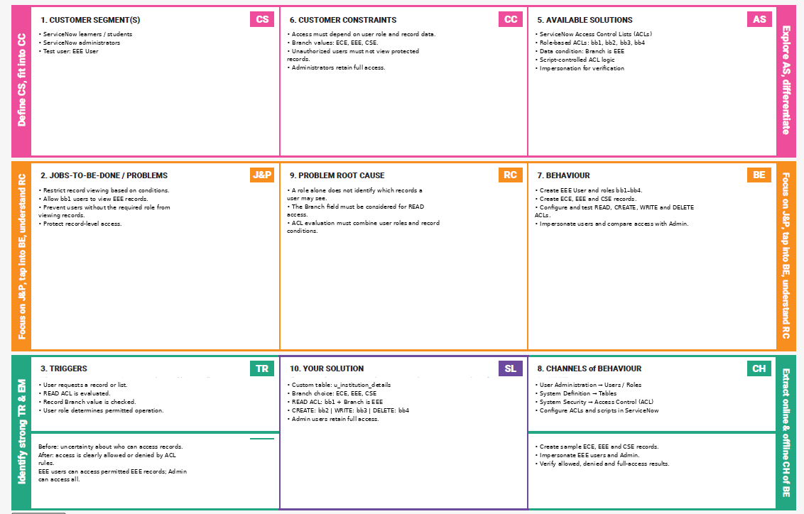

Results, Limitations and Future Enhancement

Expected result: the prototype demonstrates field-value-based record restriction through an ACL script. Advantages include dynamic authorization, record-level control, reusable logic, and clearer permission boundaries. Limitations include dependency on correct user and record data, the need for careful script testing, and the possibility of incorrect decisions if rules are misconfigured. Future enhancements can include audit logging, multiple field conditions, configurable policy tables, automated regression tests, and access reports.
Conclusion
Script-Controlled ACL provides a practical way to extend role-based authorization with record-level conditions. By checking a field such as department before returning a record, the system can distinguish between authorized and unauthorized users for the same type of data. This makes the project suitable as a college-level demonstration of dynamic access control.
References
1. Problem – Solution Fit Template v1, provided as the project reference.
2. Idea Hackers Network, Problem-Solution Fit Canvas.
3. Medium, Problem-Solution Fit Canvas.
Template note: The uploaded template contains the Project Design Phase, Problem–Solution Fit Template description, Purpose section, Template area, and References. The ACL content above adapts those elements to the stated project. fileciteturn2file0L2-L20

